#Rohitkumar pandey 211P002

import matplotlib.pyplot as plt

from matplotlib.figure import Figure

from matplotlib.backends.backend_tkagg import FigureCanvasTkAgg

import pandas as pd

import numpy as np

from sklearn.model_selection import train_test_split

from sklearn.linear_model import LinearRegression

import tkinter as tk

df = pd.read_csv("placement.csv")

root = tk.Tk()

root.title("CGPA vs Package Prediction")

root.geometry("800x600")

fig = Figure(figsize=(8, 6))

scatter_plot = fig.add_subplot(111)

x = df.iloc[:, 0].values.reshape(-1, 1)

y = df.iloc[:, -1].values

x_train, x_test, y_train, y_test = train_test_split(x, y, test_size=0.2, random_state=2)

model = LinearRegression()

model.fit(x_train, y_train)

model.score(x_test, y_test)

def predict_package():

try:

cgpa = float(entry_cgpa.get())

predicted_package = model.predict([[cgpa]])

label_prediction.config(text=f"Predicted Package: {predicted_package[0]:.2f} LPA")

except ValueError:

label_prediction.config(text="Please enter a valid CGPA")

label_cgpa = tk.Label(root, text="Enter CGPA:")

label_cgpa.pack(pady=10)

entry_cgpa = tk.Entry(root, width=10)

entry_cgpa.pack()

button_predict = tk.Button(root, text="Predict Package", command=predict_package)

button_predict.pack(pady=10)

label_prediction = tk.Label(root, text="")

label_prediction.pack(pady=10)

scatter_plot.scatter(df['cgpa'], df['package'])

scatter_plot.plot(x_train, model.predict(x_train), color='red') # Use x_train and predict on it

scatter_plot.set_xlabel('CGPA')

scatter_plot.set_ylabel('Package')

scatter_plot.set_title('CGPA vs Package')

canvas = FigureCanvasTkAgg(fig, master=root)

canvas.draw()

canvas.get_tk_widget().pack(side=tk.TOP, fill=tk.BOTH, expand=1)

tk.mainloop()

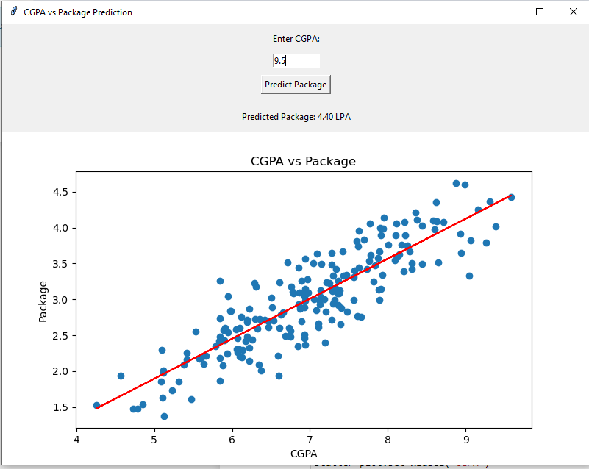

POSTLAB

1.

import matplotlib.pyplot as plt

import pandas as pd

import numpy as np

df = pd.read_csv('./placement.csv')

df.head()

# plotting the scatter plot

plt.scatter(df['cgpa'],df['package'])

plt.xlabel('CGPA') # setting x label

plt.ylabel('Package(in lpa)') # setting y label

plt.title('By Rohitkumar Pandey')

plt.show()

from sklearn.model_selection import train_test_split

# Getting cgpa values as X and pacakge as Y

X, Y= df.iloc[:,0], df.iloc[:,1]

X_train,X_test,Y_train,Y_test = train_test_split(X,Y,test_size=0.2,random_state=0)

lr_model = LinearRegression()

lr_model.fit(np.array(X_train).reshape(-1,1),np.array(Y_train).reshape(-1,1))

Y_pred = lr_model.predict(np.array(7).reshape(-1, 1))

print(Y_pred)

class LinearRegression:

def __init__(self):

self.m = None

self.c = None

def fit(self,x_train,y_train):

num, den = 0,0

x_mean, y_mean = x_train.mean(), y_train.mean()

for i in range(len(x_train)):

num = num + ((x_train[i]-x_mean)*(y_train[i]-y_mean))

den = den + ((x_train[i]-x_mean)**2)

m = num/den

c = y_mean - (m*x_mean)

self.m = m

self.c = c

def predict(self,x_test):

if self.m is None or self.c is None:

print('Model is not trained yet, Call the fit method.')

return None

return self.m*x_test + self.c

import tkinter as tk

from matplotlib.figure import Figure

from matplotlib.backends.backend_tkagg import FigureCanvasTkAgg

root = tk.Tk()

root.title("Package (in LPA) Prediction")

root.geometry('800x400')

fig = Figure(figsize=(8, 6))

scatter_plot = fig.add_subplot(111)

def predict_package():

try:

cgpa = float(entry_cgpa.get())

predicted_package = lr_model.predict([[cgpa]])

label_prediction.config(text=f"Predicted Package: {predicted_package[0][0]:.2f} LPA")

except ValueError:

label_prediction.config(text="Please enter a valid CGPA")

label_cgpa = tk.Label(root, text="Enter CGPA:")

label_cgpa.pack(pady=10)

entry_cgpa = tk.Entry(root, width=10)

entry_cgpa.pack()

button_predict = tk.Button(root, text="Predict Package", command=predict_package)

button_predict.pack(pady=10)

label_prediction = tk.Label(root, text="")

label_prediction.pack(pady=10)

scatter_plot.scatter(df['cgpa'], df['package'])

scatter_plot.plot(X_train, lr_model.predict(np.array(X_train).reshape(-1,1)), color='orange')

scatter_plot.set_xlabel('CGPA')

scatter_plot.set_ylabel('Package')

scatter_plot.set_title('Package Prediction based on CGPA By Rohitkumar Pandey')

canvas = FigureCanvasTkAgg(fig, master=root)

canvas.draw()

canvas.get_tk_widget().pack(side=tk.TOP, fill=tk.BOTH, expand=1)

tk.mainloop()

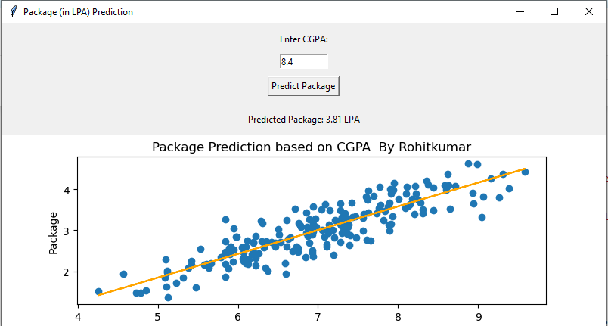

Postlab 2\\\\;

# Postlab 3

import matplotlib.pyplot as plt

import pandas as pd

import numpy as np

df = pd.read_csv('./placement.csv')

df.head()

from sklearn.model_selection import train_test_split

# Getting cgpa values as X and pacakge as Y

X, Y= df.iloc[:,0], df.iloc[:,1]

X_train,X_test,Y_train,Y_test = train_test_split(X,Y,test_size=0.2,random_state=0)

from sklearn.linear_model import LinearRegression

lr_model = LinearRegression() # Creating the model

lr_model.fit(np.array(X_train).reshape(-1,1),Y_train) # Fitting the model

# To show the errors in prediction MAE, MSE etc

import tkinter as tk

from matplotlib.figure import Figure

from matplotlib.backends.backend_tkagg import FigureCanvasTkAgg

from sklearn.metrics import mean_squared_error, mean_absolute_error, r2_score

root = tk.Tk()

root.title("Package (in LPA) Prediction")

root.geometry('800x600')

fig = Figure(figsize=(8, 6))

scatter_plot = fig.add_subplot(111)

def predict_package():

try:

cgpa = float(entry_cgpa.get())

predicted_package = lr_model.predict([[cgpa]])

label_prediction.config(text=f"Predicted Package: {predicted_package[0]:.2f} LPA")

show_errors()

except ValueError:

label_prediction.config(text="Please enter a valid CGPA")

def show_errors():

y_pred = lr_model.predict(np.array(X_test).reshape(-1, 1))

# Calculate metrics

mse = mean_squared_error(Y_test, y_pred)

mae = mean_absolute_error(Y_test, y_pred)

r2 = r2_score(Y_test, y_pred)

rmse = np.sqrt(mse)

error_text = f"Regression Metrics:- \n"\

f"Mean Squared Error (MSE): {mse:.2f}\n" \

f"Mean Absolute Error (MAE): {mae:.2f}\n" \

f"R-squared (R2): {r2:.2f}\n" \

f"Root Mean Squared Error (RMSE): {rmse:.2f}"

label_errors.config(text=error_text)

label_cgpa = tk.Label(root, text="Enter CGPA:")

label_cgpa.pack(pady=10)

entry_cgpa = tk.Entry(root, width=10)

entry_cgpa.pack()

button_predict = tk.Button(root, text="Predict Package", command=predict_package)

button_predict.pack(pady=10)

label_prediction = tk.Label(root, text="")

label_prediction.pack(pady=10)

label_errors = tk.Label(root, text="")

label_errors.pack(pady=10)

scatter_plot.scatter(df['cgpa'], df['package'])

scatter_plot.plot(X_train, lr_model.predict(np.array(X_train).reshape(-1,1)), color='orange')

scatter_plot.set_xlabel('CGPA')

scatter_plot.set_ylabel('Package')

scatter_plot.set_title('Package Prediction based on CGPA By Rohitkumar Pandey')

canvas = FigureCanvasTkAgg(fig, master=root)

canvas.draw()

canvas.get_tk_widget().pack(side=tk.TOP, fill=tk.BOTH, expand=1)

tk.mainloop()

